Dreams Hotel

**ABSTRACT**

Designing a website for a hotel that helps ease the site owner’s control over the services provided to customers, displaying many updates that the hotel provides to customers, and mentioning the most important and best services available in the hotel for all guests, in addition to effective communication with all customers to book and inquire about all the advantages and services provided in the hotel, in addition to Receiving reservation requests and responding to customer complaints and problems, in order to provide the best service to guests, while facilitating electronic payment after booking through a smartphone or personal computer that saves a lot of time and effort for customers.

**REQUIREMENTS**

|  |  |
| --- | --- |
| **Home Page** | |
| **check-in** | **select check-in date** |
| **check-out** | **select check-out date** |
| **adults** | **select adults number** |
| **check availability** | **button send to rooms page** |
| **Rooms Page** | |
| **book** | **button send to checkout page** |
| **Checkout Page** | |
| **first name** | **input first name should be at least 2 characters** |
| **last name** | **input last name should be at least 2 characters** |
| **email** | **input email should be valid** |
| **country code** | **select country code** |
| **phone** | **input phone number** |
| **credit card** | **input credit card** |
| **expired date** | **input expired date** |
| **cvv** | **input cvv** |
| **confirm** | **button send to booking voucher page** |

the requirement on the home page the check-in and check-out date and the number of adults on the room page the customer should select the room he needs to book, then he will move to the check-out Page and he fills the first, last name , mobile number, email and Visa Card details and then he will see the cancellation policy and complete the booking.

**WIREFRAMES**

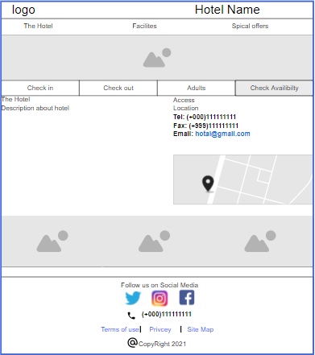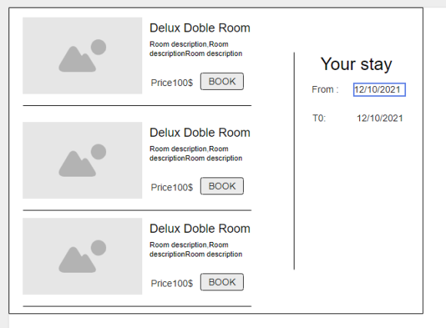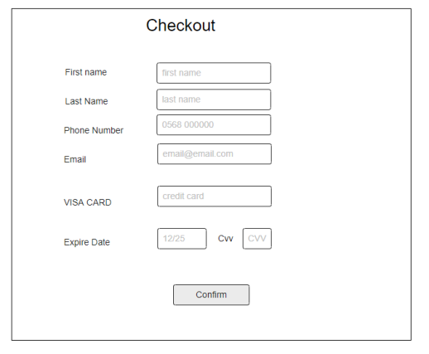

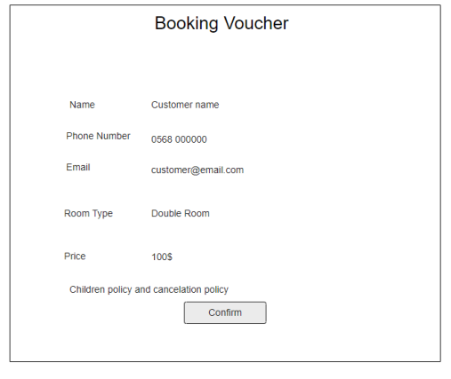

**ERD**

